**Social Baluni Public School**

Class XII (December 2020)

Biology (044)

Time allowed: 3 Hrs Maximum Marks: 70

**SECTION –A**

1. The cells of endosperm are filled with reserve food materials and are used for the 1 nutrition of the developing embryo.

Gregor Johann Mendel conducted test cross by crossing the dominant phenotypic plant with homozygous recessive parent.

1. DNA fragments are negatively charged
2. D
3. D
4. D
5. D
6. D
7. D
8. D
9. D
10. Both Assertion and Reason are true, but Reason is not the correct explanation of Assertion.

OR

Both Assertion and Reason are true but Reason, is not the correct explanation of Assertion.

1. Advantage - Assured seed set / maintain purelines = ½

Disadvantage - No variation / only parental characters are preserved / it can lead to inbreeding depression = ½

OR

Number of pollen grains produced from 20 microspore mother cells = 20 x 4 =80 pollen grains

Number of ovules produced from 20 megaspore mother cells = 20 X 1= 20 ovules

1. Air Pollution /particulate matter / dust particles released in the air.
2. Sporozoites

OR

Male , Klinefelter’s syndrome = ½ + ½

**SECTION –B**

1. Regeneration of whole plants from explants/ any part of a plant taken out and grown in a test tube, under sterile conditions in special nutrient media (containing a carbon source such as sucrose and also inorganic salts, vitamins, amino acids and growth regulators) = ½ + ½

Advantages of growing crops by tissue culture are;

recovery of healthy plants from diseased plants = ½ Mark

thousands of plants can be produced/ micropropogation = ½ Mark

OR

By crossing Saccharum officinarum / south Indian variety having desired characteristics with Saccharum barberi/north Indian low yield variety = 1

1. Fusion of an ovum containing two X-chromosomes with a Y-carrying sperm, XXY individual (47) appears.

Symptoms: A male with underdeveloped breasts, sparse body hair, mentally retarded and sterile

Association of genes on a chromosome can either be tightly linked or very loosely linked. Accordingly they show very low recombination (linkage) or higher recombination.

1. Amniocentesis is foetal sex determination test based on the chromosomal pattern in the amniotic fluid surrounding the developing embryo. This prenatal technique may be used to find out the genetic and metabolic disorders of the foetus. Unfortunately, the useful technique of amniocentesis had been misused to kill the female fetuses (female foeticide) as it could help detect gender of foetus. Hence, this technique is banned in our country. This ban is necessary as female foeticide will impact the national sex ratio. Additionally, such illegal Medical termination of pregnancy (MTP) by unqualified quakes will lead to unhealthy consequences for both the foetus and mother.

|  |  |
| --- | --- |
| **Pericarp** | **Perisperm** |
| Wall of the fruit (which develops from the wall of ovary) = 1 | Persistent residual nucellus = 1 |

OR

During fertilization, a sperm comes in contact with the zona pellucida layer of ovum and induces changes in the membrane that blocks entry of additional sperms. Thus, it ensures that only a single sperm fertilizes with an ovum.

1. Baculoviruses of genus Nucleopolyhedrovirus pathogens to insects and other arthropods. These can be used species-specific, narrow spectrum insecticide. Baculoviruses have been shown to have no negative impacts on plants, mammals, birds, fish or even on non-target insects.

**SECTION –C**

1. From the dihybrid cross, law of independent assortment can be derived which states that, when two pairs of traits are combined in a hybrid, segregation of one pair of characters is independent of the other pair of characters.
2. Memory cells produced from the first encounter , ( produce intensified, response with subsequent encounter with same pathogen) produce protein / antibodies. = ½ + ½
3. Removal of C - peptide (from pro-insulin)



1. Advanced techniques are being used now for *ex situ* conservation. Gametes of threatened species can be preserved in viable and fertile condition for long periods using cryopreservation techniques. Eggs can, thus, be fertilized *invitro.* In plants, the explants can be propagated using tissue culture methods and can be kept for long periods in seed banks.
2. Some possible reasons are:

Speciation is generally a function of time, unlike temperate regions subjected to frequent glaciations in the past, tropical latitudes have remained relatively undisturbed for millions of years and thus, had a long evolutionary time for species diversification.

Tropical environments, unlike temperate ones, are less seasonal, relatively more constant and predictable. Such constant environments promote niche specialisation and lead to a greater species diversity.

There is more solar energy available in the tropics, which contributes to higher productivity; this in turn might contribute indirectly to greater diversity.  *(Any two reasons)*

1. Sertoli cells Provide nutrition to the germ cells

Leydig cells/interstitial cells synthesise and secrete androgens (testicular hormones)

**SECTION C**

1. Test cross is a **cross** between **dominant phenotypic plant** with **homozygous recessive plant** that **determines unknown genotype** of a **dominant phenotype** of an individual.

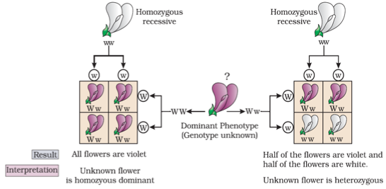

1. i: Fishes, ii: Mammal, iii: Birds, and iv: Reptiles = ½ x 4 =2 Marks
2. In-situ conservation protects organisms in their natural habitat in which biodiversity is protected at all levels.

Ex-situ conservation protects threatened animals and plants away from their natural habitat and placed in special settings where they can be protected and given special care, by keeping the gametes of threatened species preserved in viable and fertile condition for long time

1. Expressed Sequence Tags , Identifying all the genes that are expressed as RNA = ½ + ½

Sequence Annotation , sequencing the whole set of genome coding or non coding sequences and later assigning different region with functions = ½ + ½

Yeast Artificial Chromosome , used as cloning vectors (cloning / amplification ) = ½ + ½

1. When a sperm comes in contact with Zona pellucida of ovum this induces changes in the membrane that blocks entry of additional sperm , secretions of acrosome helps sperm enter into the cytoplasm of ovum through zona pellucida and plasma membrane , this induces completion of meiotic division of secondary oocyte and formation of a haploid ootid / ovum (and a second polar body) , haploid nucleus of ovum fuses with sperm nucleus to form diploid zygote (fertilization occurs)
2. DNA being very long , requires high energy for opening along its entire length = 1 + 1
3. DNA dependent DNA polymerase catalyse polymerisation only in one direction , i.e. 5’ 3’, Two strands of DNA are anti parallel and have opposite polarity = 1

**SECTION D**

1. The arrangement where a (Polycistronic) structural gene is regulated by a common promoter and regulatory genes = 1

Lactose acts as inducer , binds with repressor protein , RNA polymerase freely moves over the structural genes , transcribes lac mRNA , which in turn produce enzymes - transacetylase, permease , ß-galactosidase (by lac z) , responsible for digestion of lactose = ½ × 8

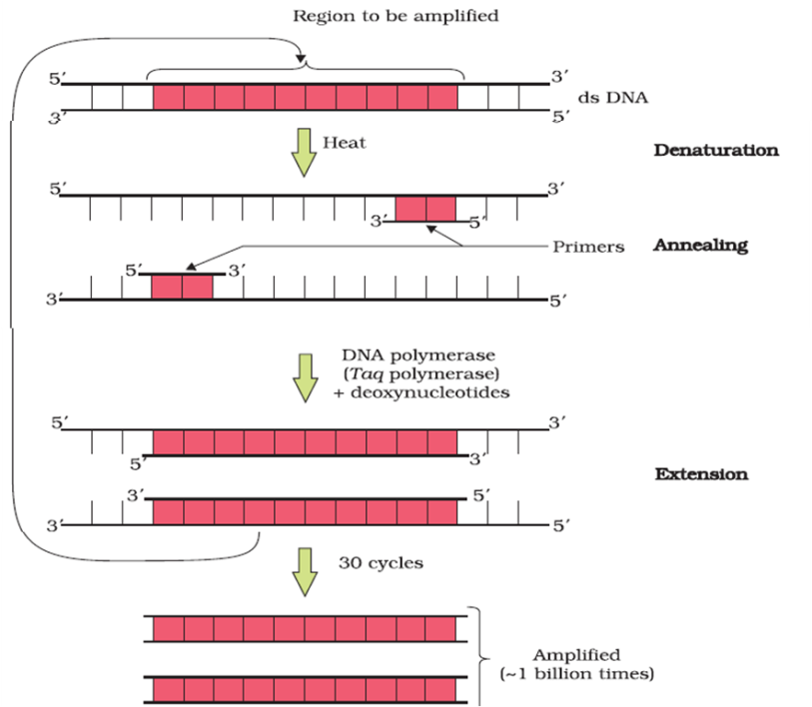

**OR**

Denaturation, Two strands of DNA are separated by heating

Annealing , Two sets of primers are attached / annealed to the separated DNA strands

Extension , Taq polymerase catalyses the extension of primers using genomic DNA as template and nucleotides provided in the reaction

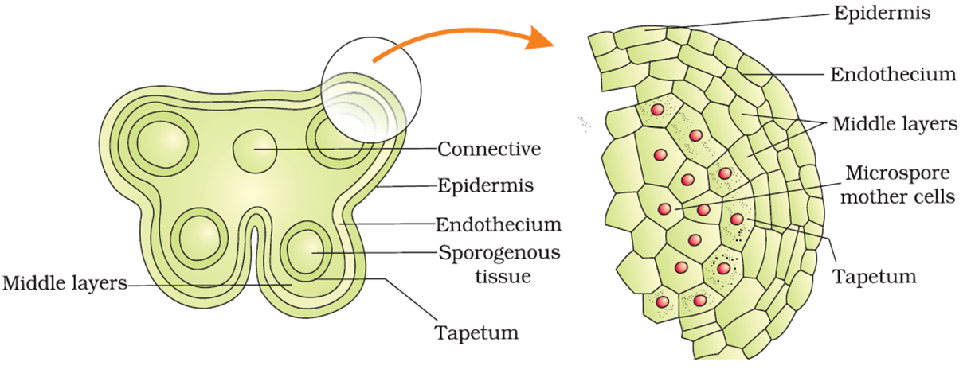

Sporogenous tissue undergo meiosis to form Microspore mother cell which in turn follow meiosis to form microspore tetrad = ½ = ½ = ½

Germ pores allow the germinating / growing pollen tube with contents of the pollen grain / male gametes + vegetative cell to come out of the pollen grains = 1

|  |  |
| --- | --- |
| Spermatogenesis  (Process of production of sperm) | Oogenesis  (Process of formation of ovum) |
| Spermatogenesis takes place from puberty to old age  A primary spermatocyte completes the first meiotic division leading to formation of two equal sized secondary spermatocytes  There is no pause at prophase I stage in spermatogenesis.  Spermatogonium produces four functional spermatozoa. | Oocytes are generated before birth in the foetus.  A large number of these oocytes degenerate during the phase from birth to puberty. The oocytes continuously decrease in number, and it gets completely exhausted at menopause.  Primary oocyte divides unequally by the first meiotic division resulting in the formation of a large haploid secondary oocyte and a tiny first polar body.  Meiotic division of secondary oocyte gets temporarily arrested at Prophase-I stage. It is completed only when a sperm comes in contact with the zona pellucida layer of the ovum.  An oogonium produces one functional ovum and three non-functional polar bodies. |

OR

|  |  |  |  |  |
| --- | --- | --- | --- | --- |
| **Phase** | **Menstrual phase** | **Follicular/proliferative phase** | **Ovulatory phase** | **Luteal phase/secretory phase** |
| Menstrual phase | **Occur menstrual flow\*** (r*esults due to break down of endometrial lining of the uterus and its blood vessels which forms liquid that comes out through vagina*)  **Lasts for 3-5 days**  \**Menstruation only occurs if the released ovum is not fertilized*  *\*Lack of menstruation may be*  *indicative of pregnancy*  *caused due to stress, poor health, etc.* | Primary follicles become **Graafian follicle.**  Gradual increase in **secretion of gonadotropins -**LH and FSH (stimulate follicular development as well as secretion of estrogens by the growing follicles).  **Endometrium** (of uterus) **regenerates** through proliferation.  *T*ransformation of primary follicles to graafian follicle and proliferation of endometrium occurs simultaneously* | **Secretion of LH and FSH attain a peak level** (about 14th day).  **Rupture of Graafian follicle**  **Occur ovulation**  *\*Rapid secretion of LH lead to* ***LH surge*** *(maximum level during the mid-cycle), which induces rupture of Graafian follicle and thereby releases ovum (ovulation).* | Graafian follicle transform as the **corpus luteum**.  Secretion of large amounts of **progesterone by corpus luteum**.  *Progesterone is essential for maintenance of the endometrium (for implantation of the fertilised ovum and other events of pregnancy).*  *In the absence of fertilisation, the corpus luteum degenerates and lead to menstruation, marking a new cycle.* |

Estrogen regulate menstrual cycle, develops secondary sexual characters

Progesterone helps in maintenance of the endometrium